What should adaptive therapy optimise? A controlled comparison of reinforcement-learning objectives

Abstract
Reinforcement-learning (RL) studies of adaptive cancer therapy each optimise a different objective in a different simulator, so the effect of the objective itself has never been isolated. We ported four published objectives into one two-population Lotka–Volterra tumour model: survival with treatment holidays (R1), dose and time (R2), sensitive–resistant coexistence (R3) and post-holiday durability (R4). We trained the same proximal policy optimisation (PPO) agent on each, with 10 seeds, and scored every policy on every objective against that objective's exact value-iteration optimum and four clinical heuristics.
At the optimum, R1, R2 and R4 select the same containment policy (time to progression, TTP, 2030–2038 days). R3 treats early and progresses about 400 days sooner (1625 d). Training on coexistence cost 12–18% of the achievable optimum on every other objective; the other three cost each other at most 2%. Durability was indistinguishable from survival on every patient tested. Trained agents reached about 85% of their optimum and outlasted the best tuned heuristic by about 50% (1740 vs 1135 d).
When the policy saw only tumour burden, PPO failed (0.21–0.37 of the optimum) until the critic received the full state during training. Those agents then beat the full-state agents, and the objectives nearly collapsed together (largest wrong-objective cost 0.035). In this model, what the agent can observe shapes the learned policy more than which published objective it optimises.

1. Introduction
Adaptive therapy treats cancer to contain it rather than to eradicate it. Drug-sensitive cells compete with resistant cells for space and resources. Withholding drug while the tumour is still tolerable keeps those competitors alive and slows the takeover by resistance [Gatenby 2009]. Preclinical models and a pilot prostate-cancer trial support the idea [Enriquez-Navas 2016; Zhang 2017], although the trial analysis is contested [Mistry 2021; Zhang 2021].
Deciding when to treat is a sequential decision problem, and reinforcement learning (RL) has been applied to it. Each study, however, defines its own objective: weeks alive plus drug-free weeks [Gallagher 2023, 2024], cumulative dose and time [Gluzman 2020], the ecological diversity of the tumour [Giles & Newton 2026], or the resistant burden after a treatment holiday [Yao 2024]. Each objective is tied to its own simulator, patient and learning algorithm. When two papers report different policies, a reader cannot tell whether the objective, the model or the learner caused the difference.
We isolate the objective. We port four published objectives into one tumour model, train one algorithm with one configuration on each, and score every resulting policy on every objective. This answers three questions:
- Do the objectives produce different policies?
- What does training on the wrong objective cost, measured on the right one?
- Does a coexistence-trained agent outlast a survival-trained one (instrumental convergence)?
Our contributions are:
- a controlled cross-evaluation of four RL objectives for adaptive therapy, with exact value-iteration optima as ceilings and tuned clinical heuristics as baselines;
- evidence that, in a two-population competition model, durability is not separable from survival, and that coexistence is the only objective that changes the policy, at a 12–18% cost on the others;
- a diagnosis of why PPO fails with a clinically realistic burden-only observation (critic aliasing), and a fix (an asymmetric actor–critic) with which burden-only agents beat full-state agents;
- the finding that the observation, not the objective, decides how much the objective matters.

2. Related work
Adaptive therapy rests on competition between sensitive and resistant cells [Gatenby 2009]. Zhang et al. [2017, 2022] ran the first adaptive trial in metastatic castrate-resistant prostate cancer with the AT50 rule: treat until PSA falls by half, then withhold until it returns to baseline. Strobl et al. [2021] showed with a two-population Lotka–Volterra model that cell turnover can stand in for a cost of resistance. Viossat & Noble [2021] analysed containment theoretically, and West et al. [2023] survey the open questions.
Optimal-control work finds that optimal schedules are typically bang-bang, with switching boundaries that depend on the full state [Gluzman 2020; Wang 2024; Cunningham 2018, 2020]. RL work learns such schedules from simulation [Engelhardt 2020; Gallagher 2023, 2024; Ma 2026]. The four studies whose objectives we port differ in every other respect too:
Study | Tumour model | Learner | Objective (our port)
Gallagher et al. 2023, 2024 | Strobl two-population LV, prostate | A3C with LSTM | weeks alive plus drug-free weeks (R1)
Gluzman et al. 2020 | three-population replicator game | dynamic programming | cumulative dose plus time (R2)
Giles & Newton 2026 | stochastic Moran process, three lineages | tabular Q-learning | population entropy (R3)
Yao et al. 2024 | tumour–immune ODE, melanoma | DDPG | regrowth after an untreated period (R4)
No study we found compares objectives in a shared environment. Partial observability has been studied separately, with recurrent agents [Kiram 2026] and with burden-only inputs plus an LSTM [Gallagher 2023]. We connect the two questions: we measure how the objective effect changes when the observation is restricted.

3. Methods

3.1 Tumour model
We use the two-population Lotka–Volterra model of Strobl et al. [2021] in the form of Gallagher et al. [2023]:
\frac{dS}{dt} = r_S S\left(1-\frac{S+R}{K}\right)\left(1-\hat d_D D\right) - d_T S, \qquad \frac{dR}{dt} = r_R R\left(1-\frac{S+R}{K}\right) - d_T R
S and R are the sensitive and resistant populations, N = S + R, and D ∈ {0, 1} is the dose. The main patient is Gallagher's proof-of-principle (PoP) patient: r_S = r_R = 0.027 per day (no cost of resistance), d_T = 0 (no turnover), drug kill factor 1.5, K = 1, N₀ = 0.75 K and an initial resistant fraction of 0.001. Cost of resistance (1 − r_R/r_S) and turnover (d_T/r_S) define the virtual-patient plane used in the robustness experiments. We integrate with fixed-step RK4 (0.5 d) and declare progression at the first substep where N ≥ 1.2 N₀.

3.2 Decision process
Every 7 days the policy chooses D ∈ {0, 1}, held for the week. The default observation is the full composition, encoded as [N/N₀, S/K, R/K, log₁₀(R/N)/4 + 1]. Episodes end at progression or after 30 years. The discount is γ = 0.999 per week, a horizon of about 19 years.

3.3 Objectives
All rewards are computed from the post-step state and scaled to about 0.1 per week.
Objective | Per-week reward | At progression | Source
R1 survival + holiday | 0.1, plus 0.05 if D = 0 | −0.1 | Gallagher 2023, Table 1
R2 dose + time | −0.1 (D + 0.01) | −101 | Gluzman 2020
R3 coexistence | +0.1 near a 50:50 mix, −0.1 near a pure tumour, else 0 | −100 | Giles & Newton 2026
R4 durability | 0.1 − 0.1 f₁₈₀ | −0.1 | Yao 2024
R1, R2 and R4 add +5 at the 30-year cap. f₁₈₀ is the resistant fraction the tumour would reach after 180 untreated days, simulated from the current state. The ports differ from the source papers in three deliberate ways. R2's progression penalty equals the discounted cost of the worst infinite future, so that dying early never pays; the literal form is optimised by never treating. R3 uses Giles & Newton's binary entropy target, scaled to R1's size. R4 is scored every week rather than once at the end, because a terminal score is nearly constant when every episode ends at the same burden.

3.4 Optimal policies
For each objective we compute the optimal policy by Howard policy iteration on a 161 × 241 grid over (N/N₀, log₁₀ f), where f = R/N. Transitions use the same step and reward code as training, with bilinear interpolation and an absorbing progression state. Policy iteration converges in 3–10 iterations. A grid with four times as many states moved no ceiling by more than 0.36%.

3.5 Learned policies
We implemented vectorised proximal policy optimisation (PPO) [Schulman 2017] with separate actor and critic networks, each two hidden layers of 128 tanh units. One configuration is used for every objective: 32 parallel environments, 128-step rollouts, 10 epochs, minibatch 512, learning rate 3·10⁻⁴ annealed to 0, clip 0.2, GAE λ = 0.99, entropy coefficient 0.01, and 10⁶ steps. Rewards are divided by a running standard deviation of the discounted return. Each objective is trained with seeds 0–9, and agents are evaluated greedily.

3.6 Baselines
Maximum tolerated dose (MTD) treats every week. AT-x treats until N < x·N₀ and then withholds until N ≥ N₀; AT50 is the trial protocol. AT-PSC, the partial-cycle rule of Ma et al. [2026], was tuned on this patient; its tuned form treats a whole 28-day cycle whenever N ≥ N₀.

3.7 Evaluation
Each policy is rolled out once on the patient and receives time to progression (TTP), dose intensity and its discounted return G under each of the four objectives. The score of a policy on an objective normalises G between no treatment and the optimum:
\text{score} = \frac{G - G_{\text{none}}}{G_{\text{VI}} - G_{\text{none}}}
Agents scoring below 0.7 on their own objective are reported but excluded from aggregates as "did not train". To compare policies, we fit a sigmoid of P(treat) against N/N₀ and compute symmetric KL divergence and greedy-action disagreement over the states that any policy visits. A pair of objectives differs if a 5000-permutation test finds the between-objective divergence larger than the within-objective (seed-to-seed) divergence for both measures, with Bonferroni correction over the six pairs.

3.8 Observation variants
Four actor inputs are compared, always with the same ceilings: the full state (E3); burden N/N₀ alone (E11); burden alone for the actor, with the critic seeing the full state during training only (E11b, an asymmetric actor–critic [Pinto 2018]); and an 8-week chart of burden readings and doses for the actor, with a full-state critic (E11c, and E11d at 3·10⁶ steps). A second round (A2) retrained the full-state and burden-plus-critic agents at 3·10⁶ steps so that all three settings could be compared at an equal budget.

3.9 Robustness and follow-up experiments
Robustness experiments vary the coexistence target (E6), use 20 held-out patients from the cost × turnover box (E7), perturb kinetic parameters by up to ±25% (E8), change the monitoring cadence to 1 or 28 days (E9), and swap the drug mechanism (log-kill, cytostatic; E10). E3c–E5c repeat the core comparison on a patient with a cost of resistance of 0.42 [Zhang 2022], and A1 on a patient with turnover 0.04. Follow-ups map the optima over a 5 × 5 cost × turnover grid (C1), add graded doses {0, 0.5, 1} and finer (D1–D3), penalise dose switches (D4), and add S→R conversion (E1) or partial drug sensitivity of resistant cells (E2). In total we trained 585 agents.

4. Results

4.1 The environment reproduces the benchmark
Continuous maximum-dose therapy progresses at 451.6 d and AT50 at 662.8 d with daily decisions, matching Gallagher et al. [2023] (450–451 d and 662 d). Our integrator agrees with a high-precision solver to within 0.01 d. Reproduction required an initial resistant fraction of 0.001, taken from the authors' code; the 0.01 in our plan gave 368.7 d and 472.8 d. With weekly decisions, AT50 reaches 673 d, AT90 932 d and the tuned AT-PSC rule 1135 d, the best heuristic.

4.2 Three objectives share one optimum
The optimal TTP is 2038 d for R1, 2030 d for R2, 1625 d for R3 and 2038 d for R4 (Figure 1). R1, R2 and R4 choose the same containment policy: let the tumour regrow and treat only when the next week would cross the progression line. R3 also treats across a wide band of low resistant fractions, to escape its penalty for a nearly pure tumour, and reaches progression about 400 d sooner.
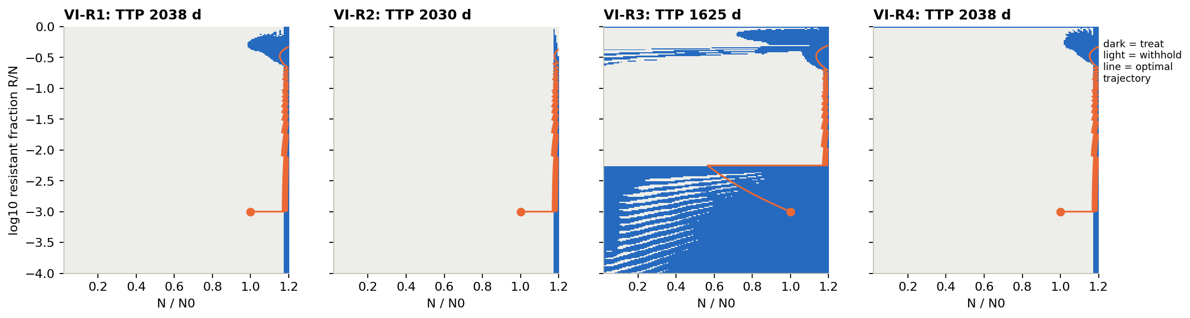
Figure 1. Optimal policies by value iteration over burden (x) and log resistant fraction (y). Dark: treat; light: withhold; line: optimal trajectory from the start state.

4.3 Training on coexistence is the costly mistake
All 40 agents trained. Median scores on their own objective were 0.87 (R1), 0.85 (R2), 0.76 (R3) and 0.87 (R4), and median TTPs 1744, 1726, 1494 and 1751 d (Kruskal–Wallis p = 1·10⁻⁵; R1, R2 and R4 did not differ after Bonferroni correction). Figure 2 scores every policy on every objective. Agents trained on R3 lose 0.12–0.18 of the achievable range on each other objective. Agents trained on R1, R2 or R4 lose at most 0.017 on each other.
The instrumental-convergence hypothesis fails (one-sided p = 1). It holds in reverse: R1-trained agents score 0.78 on the coexistence objective, above the 0.76 of R3-trained agents.
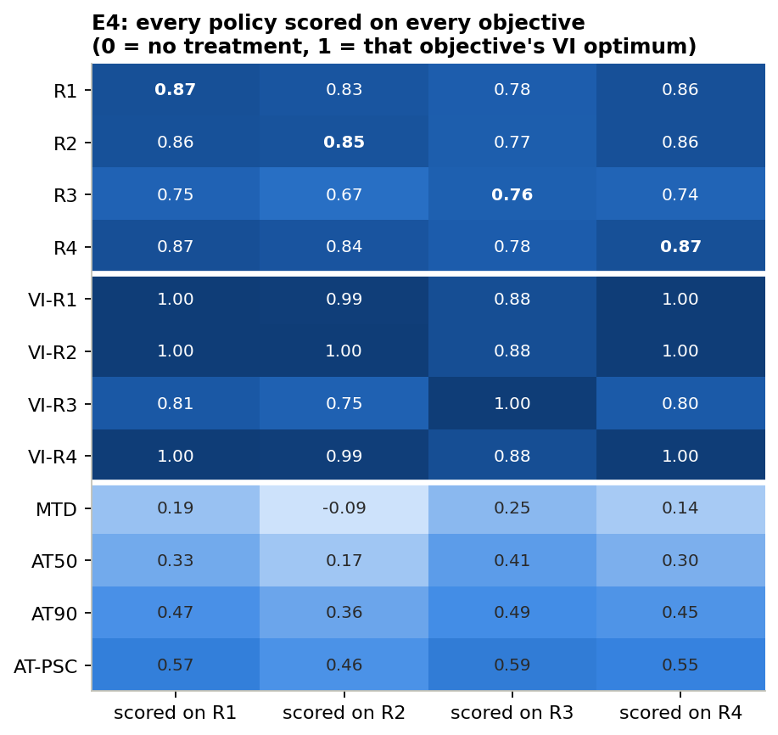
Figure 2. Cross-evaluation on the PoP patient. Rows: PPO agents (median of 10 seeds), value-iteration optima and heuristics. Columns: the objective scored. 0 = no treatment, 1 = that objective's optimum.

4.4 Policies differ, except R1 and R4
Fitted thresholds were N* = 1.144 (R1), 1.149 (R2), 1.084 (R3) and 1.146 (R4), all below the optimum's 1.174. Five of the six objective pairs differed beyond seed-to-seed noise. R1 and R2 reached the same TTP with distinguishable policies (13% greedy-action disagreement against a 4.7% noise floor). R1 and R4 did not differ. Figure 3 shows the median-seed trajectories.
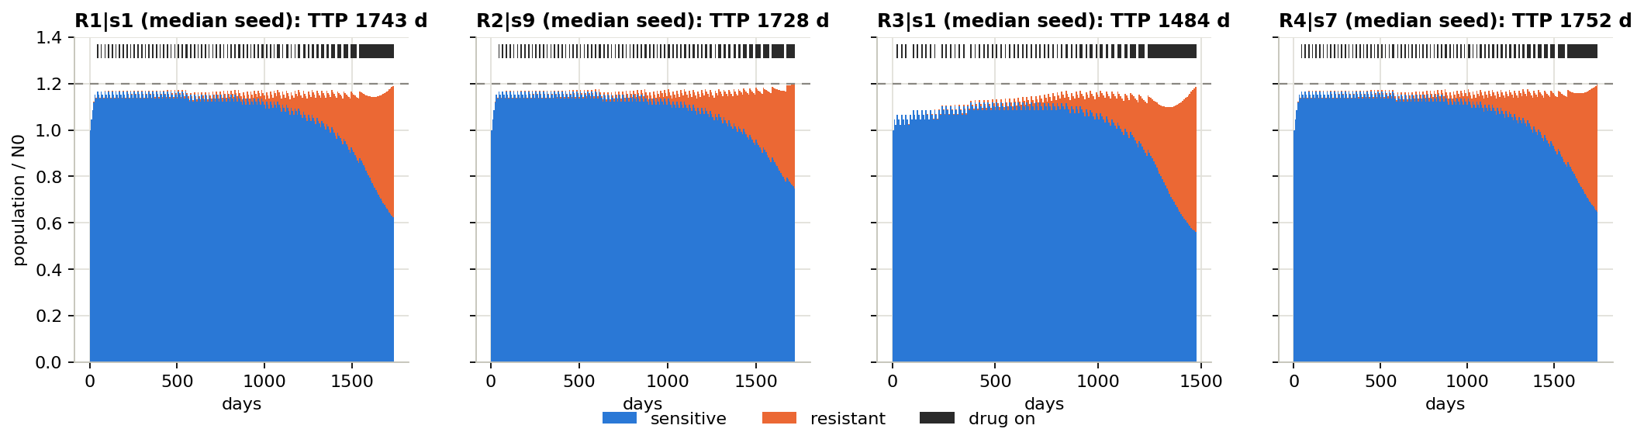
Figure 3. Median-seed trajectories. Blue: sensitive cells; orange: resistant cells; black ticks: weeks on drug; dashed line: progression at 1.2 N₀.

4.5 Durability equals survival
The R4 optimum equals the R1 optimum on the PoP patient, on the cost-0.42 patient, on the turnover-0.04 patient, and at all 25 points of the cost × turnover grid (at most 0.3% disagreement over visited states). A superseded definition based on resistant regrowth gave the same result. A heavier durability weight (0.5 or 1.0) shortened TTP only through a loophole: the episode ends where 0.1 − w·f = 0, so the agent stops treating once a week of survival scores negatively. With R2's progression penalty, the containment policy returns.

4.6 Coexistence comes last under every stress test
Stress test | Experiment | Result for R3
20 held-out patients (cost 0–0.4, turnover 0–0.04) | E7 | last for 20 of 20
Parameters perturbed by ±15–25% | E8 | still last (1450–1500 d vs 1680–1730 d)
Log-kill and cytostatic drug models | E10 | still last
Cost of resistance 0.42 | E3c–E5c | costs 0.13–0.17 on others (others ≤ 0.005)
Turnover 0.04 | A1 | costs 0.172 on others
5 × 5 cost × turnover grid (optima) | C1 | 20–23% shorter survival at every point
Progression at 1.1, 1.2 and 1.3 N₀ | B4 | 14–27% shorter survival
Smooth entropy or target-distance reward | B2 | smooth entropy is worse (1387 d)
Resistant cells partly drug-sensitive (ε ≤ 0.5) | E2 | 18–20% shorter survival
The order among R1, R2 and R4 was not stable across these tests, and we do not claim it. The reason coexistence fails is structural. In any patient who eventually progresses, the resistant population grows under every policy, so a two-population mix cannot be held. Varying the coexistence target f* from 0.05 to 0.5 changed nothing on PoP (E6), and no policy, the optimum included, held the resistant fraction above about 0.12 under a smooth target reward (B2). The optimum holds a target exactly only in patients above Strobl's controllability bound, who never progress anyway (E6b).
Two further robustness results concern the policies rather than the objectives. Under ±25% parameter error the optimum, which rides the progression line, is brittle: its lower-quartile TTP falls to about 110–160 d, while agents keep their margin. And every learned policy fails if monitored less often than it was trained (weekly-trained agents monitored monthly progress at 83 d), replicating Gallagher's asymmetry.

4.7 Observation matters more than the objective
Memoryless burden-only agents failed to train for every objective (0.21–0.37 of the optimum, TTP 535–863 d). They learned to treat whenever N exceeded 0.65–0.85 N₀, although the rule "treat if N ≥ 1.17 N₀" uses the same single input and reaches 1945 d (0.96 of the optimum). The failure is in learning: a critic that sees only burden cannot assign different values to states with the same burden and different composition. With a full-state critic during training (E11b), all 40 burden-only agents trained, each learned a sharp threshold at N* ≈ 1.15–1.16, and every objective beat its full-state counterpart (Figure 4).
Actor input | Score vs optimum | R1–R3 TTP gap | Largest wrong-objective cost
Full composition (E3–E4) | 0.76–0.87 | 250 d | 0.18
Burden only (E11) | 0.21–0.37 | did not train | not tested
Burden, full-state critic (E11b) | 0.80–0.92 | 76 d | 0.035
8-week burden chart, full-state critic (E11c) | 0.71–0.86 | 220 d | 0.105
Same at 3·10⁶ steps (E11d) | 0.80–0.92 | 235 d | 0.133
A burden-only actor cannot act on composition, which is what made R3 distinct, so the objectives nearly collapse together. Memory brings part of the effect back, but not as better service of each objective: R2- and R3-trained memory agents score no higher on their own objectives than R1-trained agents, and seed-to-seed policy noise is about four times larger. At an equal 3·10⁶-step budget (A2), the ordering is burden with full-state critic (0.97 of the R1 optimum) > full state (0.94) > memory (0.92), p ≤ 4·10⁻⁴.
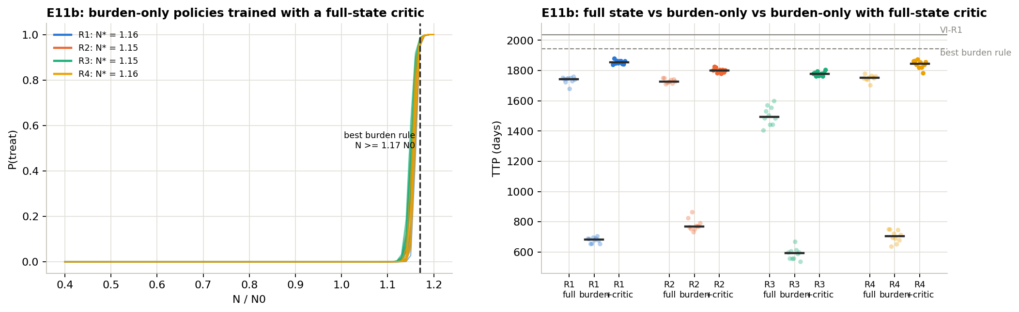
Figure 4. Left: probability of treating against burden for burden-only actors trained with a full-state critic. Right: TTP of full-state, burden-only and burden-plus-critic agents per objective (10 seeds each).

4.8 Graded doses, switching and mutation
- Graded doses (D1–D3). A half dose raises the R2, R3 and R4 optima by 70–105 d, and agents gain 68–168 d. R1 avoids the half dose because its holiday bonus pays only at D = 0, so R1 (2038 d) and R4 (2143 d) separate. A bonus proportional to the drug withheld reproduces the R4 optimum exactly. The optimum improves with more dose levels (R4: 2038, 2143, 2205 d for 2, 3, 5 levels), but PPO scores fall from 3 to 5 levels; the growth-halting dose 2/3 captures most of the gain. The size of the gain depends on the dose–response curve (R4: +56 to +112 d).
- Switching (B3, D4). Optima and agents switch dose on about 54% of weeks, heuristics on at most 22%. A switching penalty halves the switches for 3–8% of the benefit; at 9 switches a year the R1 optimum still reaches 1755 d, 55% above AT-PSC.
- Mutation (E1). With S→R conversion at 3·10⁻⁵ per day, the R4 optimum leaves a lower post-holiday resistant fraction than R1 (0.444 vs 0.490) at 6 d less TTP. This is the first separation of durability from survival, but trained agents could not detect it (p = 0.18).
- Pareto view (B1). Every good policy runs at about 72% dose intensity, so TTP is nearly linear in cumulative drug. R2's memory agents trade about 285 d for 4 points of intensity and lie on the frontier: a trade-off, not a training failure.

5. Discussion
Why containment wins. In Lotka–Volterra competition, the sensitive population is the only lever on the resistant one. Long survival, slow resistant regrowth and a low resistant fraction all improve when sensitive cells are kept as abundant as the burden limit allows. Containment does exactly that, so R1, R4 and, at its indifference margin, R2 converge on it. A durability objective that genuinely conflicts with survival needs a mechanism that makes a large sensitive population costly, such as toxicity or mutation in proportion to burden. Our mutation experiment found such a split, but it was small and invisible to trained agents.
Why coexistence fails. R3 encodes a sound intuition, that resistance is contained by keeping competitors alive, but rewards the wrong quantity. Entropy peaks at a 50:50 mix, which is a state of advanced resistance, and in a progressing patient the resistant fraction rises under every policy. The reward therefore reduces to "treat early, then contain", which costs survival. That survival-trained agents collect more coexistence reward than coexistence-trained ones shows the objective is also harder to learn. Diversity objectives may fit stochastic finite-population models, where drift can eliminate the sensitive population [Giles & Newton 2026], better than a deterministic two-population model.
Observation decides how much the objective matters. With the full composition, an agent can act on R3's target, and the objectives diverge. With burden only, every objective reduces to one threshold on burden, and the differences shrink to a few percent. Clinical observations are burden-like (for example PSA), so in practice the observation, monitoring cadence and training method may matter more than the choice among these objectives. The asymmetric actor–critic is a cheap remedy for simulation-trained clinical policies: the simulator's full state is available during training, and only the deployed policy must work from clinical data.
Margins and robustness. The exact optimum rides the progression line and fails badly when the patient differs from the planning model. Trained agents keep a margin of about 0.03 N₀, which costs about 15% of nominal TTP but keeps them robust to ±25% parameter error and to different drug mechanisms. Model-based optima should not be deployed without such a margin, and any policy must be monitored at least as often as it was trained.
Clinical legibility. Optimal schedules change dose on about half of all weeks. A switching penalty yields schedules with about 9 switches a year at a 3–8% cost, still 55% above the best heuristic, which suggests that simple, executable schedules give up little.

6. Limitations
- One model class, in silico. Two well-mixed populations with pre-existing, binary resistance. There is no space, pharmacokinetics or phenotypic plasticity, and mutation appears only in one follow-up.
- Few patients for the full matrix. The complete cross-evaluation was run on three reference patients (PoP, cost 0.42, turnover 0.04). The held-out cohort and the 25-point map cover cost ≤ 0.4 and turnover ≤ 0.04, the latter with optima only.
- Oracle observation in the main comparison. The headline objective effects are measured with the full composition, which clinicians cannot observe; Section 4.7 shows they shrink under a burden-only observation.
- The ports are interpretations. R2's progression penalty, R3's scaling and boundary, and R4's weekly form are our choices, and the findings are about these ports.
- Discretised ceiling. The value-iteration optimum is computed on a grid, so agents can in principle exceed it slightly; a 4× finer grid moved ceilings by under 0.4%.
- Fixed training budget and one algorithm. Long episodes were under-trained at 10⁶ steps (5 of 10 R3 seeds failed on the cost-0.42 patient). The equal-budget rerun at 3·10⁶ steps left the orderings unchanged. Only PPO was tested.
- No clinical claim. Adaptive therapy itself is not clinically established [Mistry 2021].

7. Conclusion
In one environment with one learner, survival, dose and durability objectives converge on the same containment policy. Coexistence is the outlier: it costs 12–18% on every other objective and never beats survival-training, even on its own reward. Durability is indistinguishable from survival on every patient we tested. When the policy sees only tumour burden, as a clinician does, the objective effect shrinks to a few percent, provided the critic sees the full state during training. For simulation-trained adaptive-therapy policies, the observation and the training method deserve as much care as the reward.
Next steps, in order of relevance:
- Noisy or delayed burden readings, since observation is the strongest lever in this study.
- PPO on the dose set {0, 2/3, 1}, where 2/3 exactly halts sensitive growth and captured most of the planner's graded-dose gain.
- PPO with the previous dose in the observation, to learn switching costs that we solved only by value iteration.
- A toxicity objective, or a model in which a large sensitive population is costly, as the route to a durability objective that conflicts with survival.

References
- Cunningham JJ, Brown JS, Gatenby RA, Stanková K. Optimal control to develop therapeutic strategies for metastatic castrate resistant prostate cancer. J Theor Biol. 2018.
- Cunningham J, Thuijsman F, Peeters R, Viossat Y, Brown J, Gatenby R, Stanková K. Optimal control to reach eco-evolutionary stability in metastatic castrate-resistant prostate cancer. PLOS ONE. 2020.
- Engelhardt D. Dynamic control of stochastic evolution: a deep reinforcement learning approach to adaptively targeting emergent drug resistance. J Mach Learn Res. 2020.
- Enriquez-Navas PM, Kam Y, Das T, et al. Exploiting evolutionary principles to prolong tumor control in preclinical models of breast cancer. Sci Transl Med. 2016.
- Gallagher K, Strobl M, Gatenby R, Maini P, Anderson A. Learning to adapt — deep reinforcement learning in treatment-resistant prostate cancer. bioRxiv 2023.04.28.538766. 2023.
- Gallagher K, Strobl MAR, Park DS, Spoendlin FC, Gatenby RA, Maini PK, Anderson ARA. Mathematical model-driven deep learning enables personalized adaptive therapy. Cancer Res. 2024.
- Gatenby RA, Silva AS, Gillies RJ, Frieden BR. Adaptive therapy. Cancer Res. 2009.
- Giles M, Newton PK. Reinforcement learning for chemotherapy scheduling in a stochastic tumor evolution model. Phys Rev E. 2026;113:064404.
- Gluzman M, Scott JG, Vladimirsky A. Optimizing adaptive cancer therapy: dynamic programming and evolutionary game theory. Proc R Soc B. 2020;287:20192454.
- Kiram FME, et al. Recurrent deep reinforcement learning for chemotherapy control under partial observability. arXiv 2605.02552. 2026.
- Ma, Wang, Yang, Cheke, Tang. Single-threshold-guided adaptive cancer therapy with partial-cycle treatment: a mechanistic and reinforcement learning analysis. PLOS Comput Biol. 2026;22(6):e1014457.
- Mistry HB. On the reporting and analysis of a cancer evolutionary adaptive dosing trial. Nat Commun. 2021.
- Pinto L, Andrychowicz M, Welinder P, Zaremba W, Abbeel P. Asymmetric actor critic for image-based robot learning. Robotics: Science and Systems. 2018.
- Schulman J, Wolski F, Dhariwal P, Radford A, Klimov O. Proximal policy optimization algorithms. arXiv 1707.06347. 2017.
- Strobl MAR, West J, Viossat Y, et al. Turnover modulates the need for a cost of resistance in adaptive therapy. Cancer Res. 2021.
- Viossat Y, Noble R. A theoretical analysis of tumour containment. Nat Ecol Evol. 2021.
- Wang M, Scott JG, Vladimirsky A. Threshold-awareness in adaptive cancer therapy. PLOS Comput Biol. 2024.
- West J, Adler F, Gallaher J, et al. A survey of open questions in adaptive therapy: bridging mathematics and clinical translation. eLife. 2023.
- Yao, Chen, Zhang. Optimized patient-specific immune checkpoint inhibitor therapy based on tumor immune microenvironment modeling. Brief Bioinform. 2024. doi:10.1093/bib/bbae547.
- Zhang J, Cunningham JJ, Brown JS, Gatenby RA. Integrating evolutionary dynamics into treatment of metastatic castrate-resistant prostate cancer. Nat Commun. 2017.
- Zhang J, Cunningham JJ, Brown JS, Gatenby RA. Response to Mistry. Nat Commun. 2021.
- Zhang J, Cunningham J, Brown J, Gatenby R. Evolution-based mathematical models significantly prolong response to abiraterone in metastatic castrate-resistant prostate cancer. eLife. 2022.
Open before submission: volume and page numbers for most entries, and full author lists for Ma 2026 and Yao 2024.

